**Project Design Phase-II**

**Data Flow Diagram & User Stories**

|  |  |
| --- | --- |
| Date | 28 June 2025 |
| Team ID | LTVIP2025TMID59356 |
| Project Name | FlightFinder :Navigating Your Air Travel Options |
| Maximum Marks | 4 Marks |

**Data Flow Diagrams:**

A Data Flow Diagram (DFD) is a traditional visual representation of the information flows within a system. A neat and clear DFD can depict the right amount of the system requirement graphically. It shows how data enters and leaves the system, what changes the information, and where data is stored.

**Example:** [**(Simplified)**](https://developer.ibm.com/patterns/visualize-unstructured-text/)

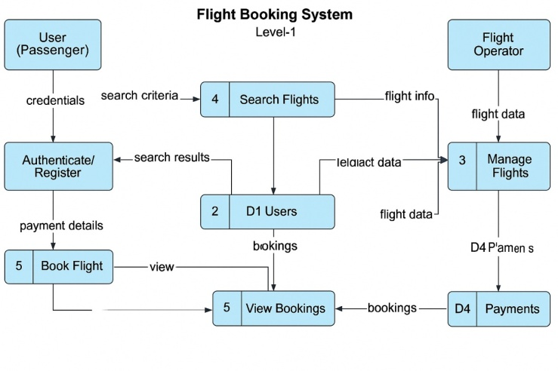

**User Stories**

Use the below template to list all the user stories for the product.

| **User Type** | **Functional Requirement (Epic)** | **User Story Number** | **User Story / Task** | **Acceptance criteria** | **Priority** | **Release** |
| --- | --- | --- | --- | --- | --- | --- |
| Customer (Mobile user) | Registration | USN-1 | As a user, I can register for the application by entering my email, password, and confirming my password. | I can access my account / dashboard | High | Sprint-1 |
|  |  | USN-2 | As a user, I will receive confirmation email once I have registered for the application | I can receive confirmation email & click confirm | High | Sprint-1 |
|  |  | USN-3 | As a user, I can register for the application through Facebook | I can register & access the dashboard with Facebook Login | Low | Sprint-2 |
|  |  | USN-4 | As a user, I can register for the application through Gmail | I can register & access the dashboard with Gmail login | Medium | Sprint-1 |
|  | Login | USN-5 | As a user, I can log into the application by entering email & password | I can access my account/dashboard | High | Sprint-1 |
|  | Dashboard | USN-6 | As a user, I can view my profile, bookings, and notifications in the dashboard | I can see my profile, upcoming bookings, and relevant alerts | High | Sprint-2 |
| Customer (Web user) | Registration | USN-7 | As a web user, I can register using email and password | |  | | --- | | I can register and receive  confirmation mail |  |  | | --- | |  | | High | Sprint-2 |
| Customer Care Executive | Dashboard | USN-8 | As a CCE, I can view customer issues and complaints from the dashboard | I can see tickets/issues with status | Medium | Sprint-3 |
| Administrator | Issue Management | USN-9 | As a CCE, I can resolve or escalate issues raised by customers | I can update issue status or assign to admin | High | Sprint-2 |
|  | Reports & Analytics | USN-10 | As an admin, I can manage all users including blocking or deleting accounts | I can view, block, or delete any user | Medium | Print-3 |